|  |  |
| --- | --- |
| **Name** | **Power Consumption** |
| Raspberry Pi Pico | 0.040A |
| Arduino Nano | 0.093A |
| Raspberry Pi | 1.2A (USB) <- |
| Regulator Output | 5A |

# Power Consumption

# I2C

|  |  |  |
| --- | --- | --- |
| **Name** | **I2C Address** | **GPIO** |
| VL53L0X_1 | 0x35 | G14 |
| VL53L0X_2 | 0x36 | G19 |
| VL53L0X_3 | 0x37 | G21 |
| VL53L0X_4 | 0x38 | G26 |
| VL53L0X_5 | 0x3A | G27 |
| VL53L0X_6 | 0x3B | G28 |
| TMF8801_1 | 0x41 |  |
| VLX53L1X_1 | 0x24 | G1 |
| VLX53L1X_2 | 0x25 | G2 |
| Gyroscope | 0x68 |  |
| Compass | 0x18 |  |

TMF8801: These sensors are generally much more accurate compared to the VL53L0X sensors; however, they are much slower in taking measurements. <- We can set up an interrupt system for these sensors. While the system is not being interrupted the other sensors should work as normal.

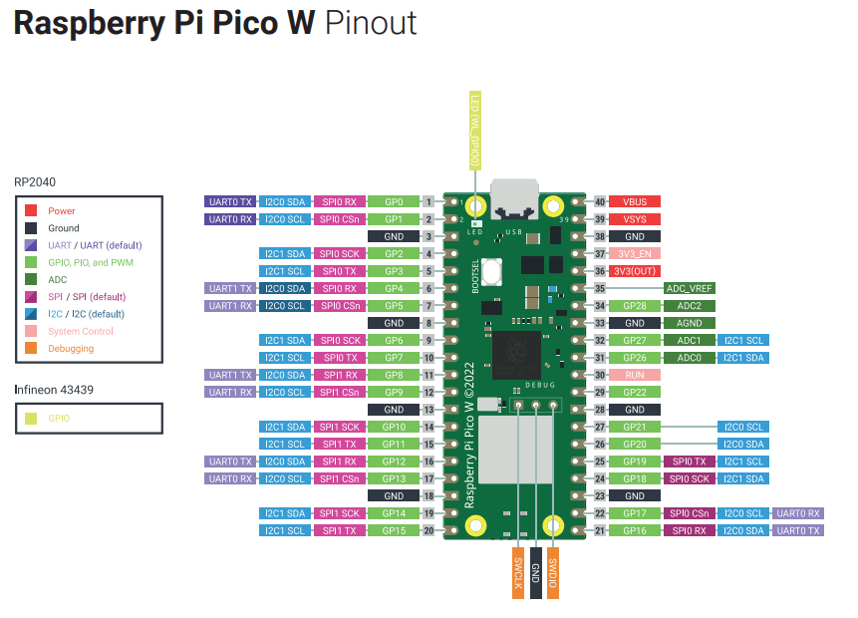

|  |  |
| --- | --- |
| GPIO Number | Function |
| GPIO0 | SDA |
| GPIO1 | SCL |
| GPIO2 | VL53L1X (1) |
| GPIO3 | VL53L1X (2) |
| GPIO4 | IMU |
| GPIO5 |
| GPIO6 |
| GPIO7 |
| GPIO8 | Display |
| GPIO9 |
| GPIO10 |
| GPIO11 |
| GPIO12 |
| GPIO13 |
| GPIO14 | VL53L0X (2) |
| GPIO15 | Button |
| GPIO16 | Joystick |
| GPIO17 | Button |
| GPIO18 | Joystick |
| GPIO19 | VL53L0X (2) |
| GPIO20 | Joystick |
| GPIO21 | VL53L0X (3) |
| GPIO22 | FSYNC Pin |
| GPIO26 | VL53L0X (4) |
| GPIO27 | VL53L0X (5) |
| GPIO28 | VL53L0X (6) |

26 pins in totals

5 pins for the VL53L0X

* VL53LOX will utilize a shutdown based system that is the sensor will be called routinely

## 3 pins for the TMF8801

* TMF8801 Will utilize an interrupt-based system that is the system will only be called whenever the sensor detects a signal.

# Madgwick filter

* It always had the problem of drifting which cannot really be resolved in real life.
* 8 Minutes can result in around 20 degrees worth of drift in yaw if the system is positioned **stationarily.**
* 8 Minutes can result in around 20 degrees worth of drift in yaw if the system is moving dynamic